Name __________________________ Date __________________________
Section _________________________ LAB: CREATE YOUR OWN WATER CYCLE
QUESTION: How does the water cycle work?
______________: Water on Earth is always changing. Its repeating changes make a cycle. As water goes through its cycle, it can be a solid (ice), a liquid (water), or a gas (water vapor). Ice can change to become water or water vapor. Water can change to become ice or water vapor. Water vapor can change to become ice or water. Adding or subtracting heat makes the cycle work. If heat is added to ice, it melts. If heat is added to water, it evaporates. Evaporation turns liquid water into a gas called water vapor. If heat is taken away from water vapor, it condenses. Condensation turns water vapor into a liquid. If heat is taken away from liquid water, it freezes to become ice.
HYPOTHESIS: ___________________________________________________________________________ ________________________________________________________________________________________
EXPERIMENT:
____________: water, measuring spoons, plastic bag, (if plastic bag is not a zip lock…. rubber band)
PROCEDURE:
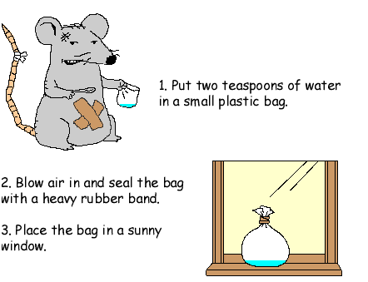
4. Observe for 2 days. Record observations a minimum of 3 times each day.
DATA COLLECTION:
ANALYSIS:
CONCLUSION:

