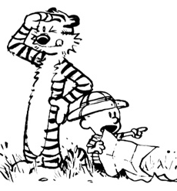
Science Safety
Directions about safety make sure everyone is safe & on the same path. A lost scientist is a disaster waiting to happen! Before you begin any science experiment, review the safety steps.

- Eating and drinking in the laboratory is not allowed.
- Follow all instructions carefully. If you're uncertain, ASK!
- Safety goggles must be worn to protect your eyes.
- Long hair must be tied back.
- Leave all your belongings off the lab table.
- To avoid accidents, always walk.
- When leaving a lab station, push chairs in.
- Speak in a voice that can only be heard by your lab partners.
- Clean up. Put away all your equipment. clean your lab table. Place waste materials in the correct containers.
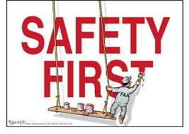
10. Wash your hands.

