Riddle Me This
10 points

WHAT IT IS:
A Riddle is a type of poem that describes something without actually naming what it is, leaving the reader to guess. Riddles can be about anything.

TO DO:

- Choose 5 vocabulary words from our current topic.
- Go to the web site & follow the directions.

This can be done using the internet. Use the web site located at: http://www.readwritethink.org/files/resources/interactives/riddle/

EXAMPLES:

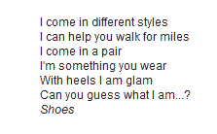 | “What animal walks on all fours in the morning, two in the afternoon and three in the evening?”  The answer is man, since he crawls as a child then walks and uses a cane when he gets older. | 