Game Maker
5 points

WHAT IT IS:
Invent a game that could have been played in the culture we are learning about.

TO DO:
Invent a game that could have been played in the culture we are learning about. Be sure to think about the type of materials that would be available, the geography of where you would play the game & who would be playing this game.

- At the top of your paper give your game a name and write where it will be played.
- Write out a basic description of the game and the basic rules. Make sure to include all the rules needed to play the game. (Who goes first? How do you keep score? When does it end? Etc.)
- Describe the equipment you would need and what it would be made out of.
- Include a picture of your game being played.
This can be done by hand or on the computer.

EXAMPLE:
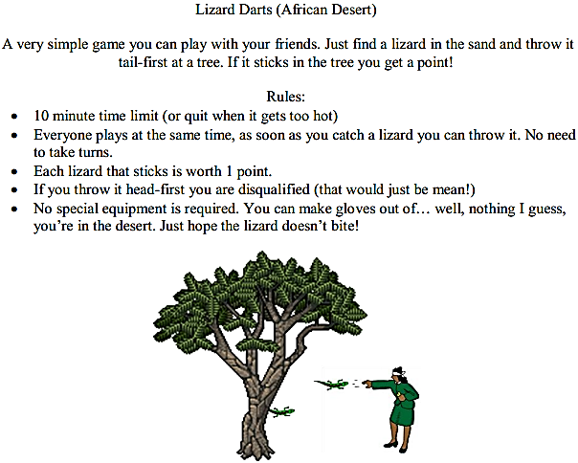
Picture credit to Mr.Roughton.com

