Diamante Poem
5 points
WHAT IT IS:

TO DO:
- Choose a topic from our current area of study.
- Follow the following format.
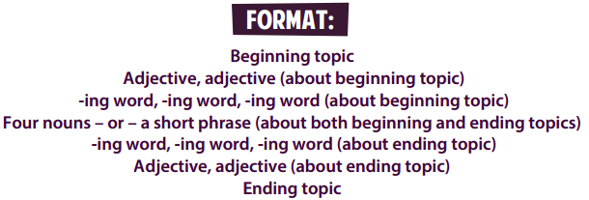
This can be done by hand, on the computer or using the internet. IF you want to use the internet use the web site located at: http://www.readwritethink.org/files/resources/interactives/diamante_poems_2/

EXAMPLE:
