Comic Strip
10 points

WHAT IT IS:
Illustration of an event from the current culture.

TO DO:

- Create a comic strip of at least 5 panels.
- Plan the panel carefully. Make sure you have a wholes tory to tell.
- Each panel should be fully colored.
- Background should indicate where the event takes place.
- No stick figures.
- Each panel should contain at least 1 speech bubbles &/or other text.

This can be done by hand, on the computer or using the internet.
If you want to use the internet try: http://www.pixton.com/collection/Pixton or http://www.makebeliefscomix.com/Comix/

EXAMPLE:
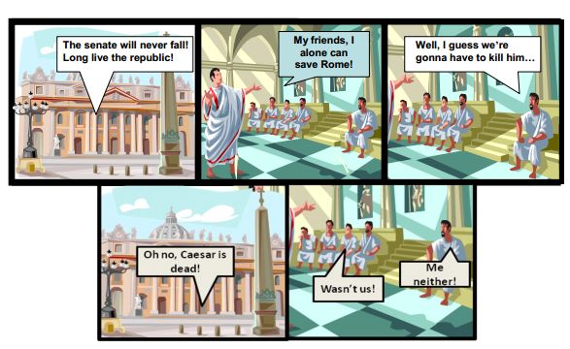
Comic credit to Mr.Roughton.com

