Bumper Sticker
5 points

WHAT IT IS:
While out & about, you probably have seen cars with bumper stickers. They are usually colorful and are trying to make a point.

TO DO:
Create your bumper sticker based on a short statement from the culture we’ve been studying. This can be drawn by hand or on the computer.
Make sure the bumper sticker is:
- Related to the Unit
- Colorful
- Thoughtful
On the back of your bumper sticker write an explanation of what your bumper sticker means and why you wrote it.

EXAMPLE:

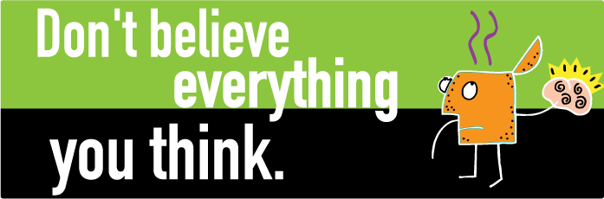

Explanation: On the back of your bumper sticker write an explanation of what your bumper sticker means and why you wrote it.

