Travel Brochure
20 points

WHAT IT IS:
Create a brochure to advertise for the current culture we are learning about.

TO DO:

- Create a trifold travel brochure that will entice people to come & visit this culture. Write this in the present tense… as if the culture is still alive & well. 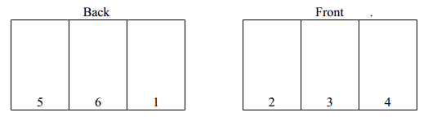
- Create 6 panels of text & graphics that include the following:
  - PANEL 1: Front cover = Name & picture of location
  - PANEL 2: History = briefly describe the important events of this culture. Include a map of the location.
  - PANEL 3: Accommodations & Dining = describe where the visitor will stay & what types of food there is to eat
  - PANELS 4 - 6: To Do & See = What attractions are there to see? What is there to do? Describe the “Can’t Miss This” things there are to see & do.

This can be done by hand, on the computer or using the internet. Try this on line by using the web site http://www.readwritethink.org/classroom-resources/student-interactives/printing-press-30036.html

EXAMPLE:
