Name __________________________ Date_____________________
Section __________ Subject: The Universe & Beyond
You can use the Scientific Method to complete the Universe & Beyond Project.
- Ask 1 or 2 questions you want to know about the topic.
- These are your focus questions.
Research | - Keep track of all the resources you use. You need to give credit to the people whose information your use. Don't plagiarize!  - Take notes. (You'll need more than this little box!)  - Time Saver: Learn CUT * COPY * PASTE in Microsoft Word!
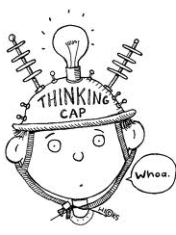  Hypothesis | - What do you think the answer is/are to your question(s)?  - What do you know about this topic?
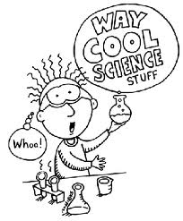  Experiment | - Start putting it all together.  - what type of writing are you going to do?  - Who is your audience?  - Take your notes & piece them together.  - Ask yourself is it logical? Does this make sense?  - What type of project will you create?
Analysis | - Check over the work completed thus far.  - Get someone else to check over your work.  - Ask for constructive criticism & listen to what you are being told. How does it help you?
Conclusion | - Completion: the best of the best  - Best writing.  - Best creation.
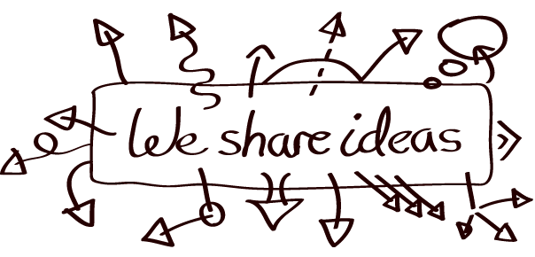Compare/Share | - Show-off time.  - You are the expert… inform us!

Finally:
Technology | - Some form of technology must be used. Typing does not count.  - use the Technology Resources we discuss… located on our web site under technology
Writing | - only your best will be accepted  - type or write  - style can be whatever you want as long as you answer your question(s) completely
Project | - needs to be something creative (no shoe box dioramas, poster, mobiles!)  - technology works great here…consider something new…step outside your comfort zone
? | - Is there a way to combine the technology & project & writing?  - Sure there is! Figure something out!  - Not sure? ASK… but don’t wait until the last minute!

Important Dates:
Class in Computer Lab: Oct 12 & 18
Class in MMS Library: Oct 11 & 19
You go to Mahopac Library: By Oct 14th
Project Due Oct 29th
Questions, Comments, Concerns: _______________________________________________________________________________________________
____________________________________________________________________________________________________________________________________

