Name__________________________________
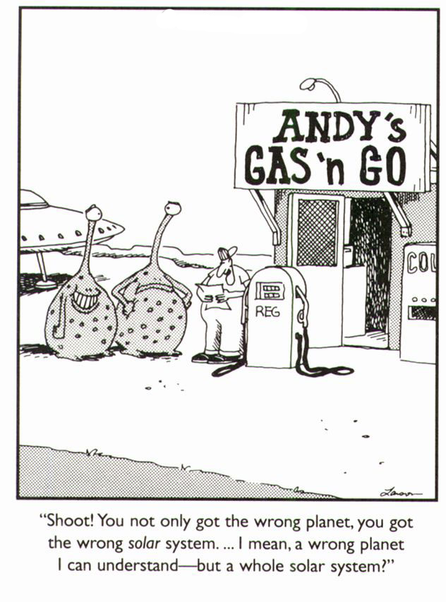
Section_______ Date___________
Space: the final frontier. These are the voyages of the starship TEAM 6D. Its continuing mission: to explore strange new worlds, to seek out new life and new civilizations, to boldly go where no one has gone before!
The Universe & Beyond
You are about to embark on a journey and become an expert on a part of “Space Science” that you are most interested in. For the next few weeks you will conduct research so that you can become an expert on this topic. We will go to the MMS Library, use the computer labs & some class time to work on this. In order to complete this project, you will need to do some work at home. Best practice: Set up a plan for yourself, budgeting your time around all of your other commitments… but become that expert & do it on time.
- The topic I chose is ______________________________________________. I chose this topic because _____________________________________________________________.
- What challenges do you foresee in completing this Expert Project & what will you do to overcome them? ___________________________________________________________________ ____________________________________________________________________________________ ____________________________________________________________________________________
- What types of materials / resources will you use to become an expert on your topic? ___________________________________________________________________________________ ____________________________________________________________________________________
- What will you write that will reflect what you learned from your research? ___________ ____________________________________________________________________________________ ____________________________________________________________________________________
- What will you create that will reflect what you learned from your research? _________ ________________________________________________________________________________________________________________________________________________________________________
- Describe the time line for your project.
  - Research will be completed by: _________________________________________
  - Writing will be completed by: _________________________________________
  - Project will be completed by: _________________________________________
  - Entire Expert Project completed by: OCTOBER 29, 2012
Questions, Comments, Concerns: __________________________________________________________________________________________
__________________________________________________________________________________________

