Cooking up a Civilization
10 points

WHAT IT IS:
Write a “recipe” for the creation of a particular historical culture or civilization.

TO DO:
- Write a “recipe” for the creation of a particular historical culture or civilization. Include the “ingredients” that went into forming that civilization and any special instructions for bringing them together.
- You Must:
- Include at least two people
- Include at least 10 total ingredients
- Write out at least 5 step-by-step directions for creating the civilization
This can be done by hand or on the computer.

EXAMPLE:
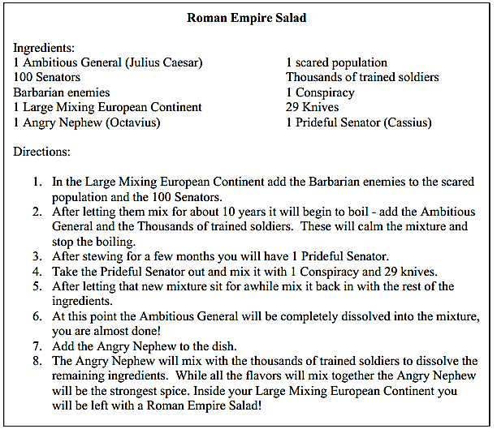
Source:Mr.Roughton.com

