Magazine Cover
20 points

WHAT IT IS:
Create a cover for a magazine that would have been published during the time period we are currently learning about.

TO DO:

- The final product of the magazine should be neatly created & free of errors. It should look like a real magazine cover. Look at a few to get layout ideas.
- The cover should include the following:
  - Title & publication date
  - Main graphic
  - At least 2 important people & a blurb about them
  - At least 2 intriguing questions about the culture that will want to entice people to read the articles
  - At least 2 bold statements about the culture that will want to entice people to read the articles
  - At least 2 graphics to go w/ either the about questions &/or statements from (c & d)
  - Anything else???

This can be done by hand or on the computer

EXAMPLE:
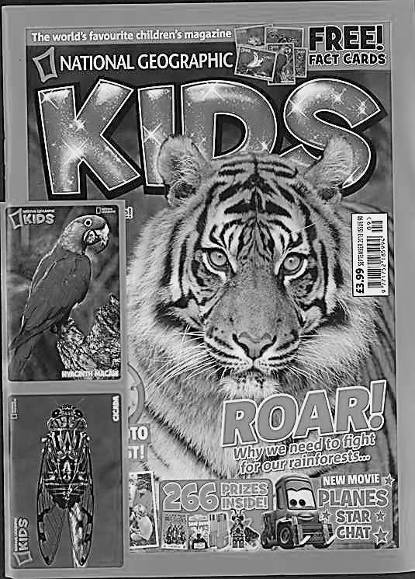
2 blurbs on people (C)
2 side graphics (F)
2 statements (E)
Main Graphic (B)
2 questions (D)
Magazine Title (A)

