Lost World
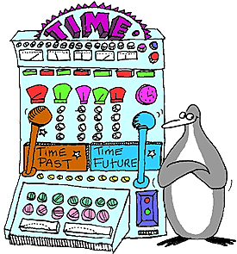
10 points

WHAT IT IS:
Imagination meets reality in this story.

TO DO:

- Imagine that you boarded your personal time travel machine & programed it to end up in the culture we are currently studying (Think Ms. Frizzle & the Magic School Bus)
- Write a story in which you accurately explain what you see in this culture. Include the following questions & anything else that you would like in your story.
  - What would a person like you spend most of his or her time doing in this civilization?
  - Draw & describe in words what clothing you would wear.
  - Describe some of the foods you would eat & how you would obtain this food.
  - Describe where would a person like you be living & with whom would you be living with?
- Based on your answers and research would you want to go back in time to live in this civilization? Why or why not?
Give credit to the resources you use to provide accurate information about this culture.

This can be done by hand on the computer.

EXAMPLE:
