Leonardo DaVinci's Vitruvian Man
QUESTION: How does your height compare to your arm span? Are you a square, a wide rectangle or a tall rectangle? How do you compare to your classmates? Are Vitruvius & DaVinci correct?
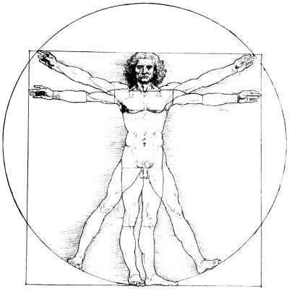
RESEARCH: View power point on DaVinci. Leonardo DaVinci's Vitruvian Man states that Vitruvius, the architect, says in his work on architecture that the measurements of the human body are distributed by Nature as follows that is that:
- 4 fingers make 1 palm
- 4 palms make 1 foot
- 6 palms make 1 cubit
- 4 cubits make a man's height
- 4 cubits make one pace
- 24 palms make a man
- If you open your legs so much as to decrease your height 1/14 & spread & raise your arms till your middle fingers touch the level of the top of your head you must know that the centre of the outspread limbs will be in the navel & the space between the legs will be an equilateral triangle
- The length of a man's outspread arms is equal to his height.
- etc…
Hypothesis: _________________________________________________________________
Experiment:
- With a partner, prove or disprove your hypothesis.
- Use both standard & metric measure.
- Record your data.
- Add your data to the class data base.
  - If the length of a your outspread arms is equal to your height, then you are a square.
  - If your arms are longer than your height then you are a wide rectangle.
  - If your height is longer than your arms, you are a tall rectangle.

Analysis: Create a graph of the class data. (Helpful hint: y axis = height & x axis = arm span)
Conclusion: In complete sentences, answer the questions posed in the PROBLEM.
Share/Compare:
EXTRA: Test out some of the other calculations posed by Vitruvius & DaVinci
Leonardo DaVinci's Vitruvian Man Class Data
NAME | SQUARE | TALL RECTANGLE | WIDE RECTANGLE
Class Totals

