Art Analysis
5 points

WHAT IT IS:
Choose a piece of art that complements the current time period we are learning about & analyze it.

TO DO:
Supply a copy of the art or a way for me to look at it. Answer the following questions in complete sentences.

- Where did you find the art? (Chapter title and page number, internet web site, etc.)
- What type of art is it? (Modern photograph, old painting, modern illustration, etc.)
- Describe what exactly do you see in the art?
- If there are people involved, how are the people dressed? Explain what are they doing?
- Imagine you are in the art. Make connections & explain what might you hear, smell & taste?
- What is unique about this image that the artist / photographer wanted to capture?
- What made you choose this piece of art?
- What do you personally think of this piece of art?

This can be done by hand or on the computer or using the internet. A great web site for art is http://www.metmuseum.org/collection/the-collection-online

EXAMPLE:
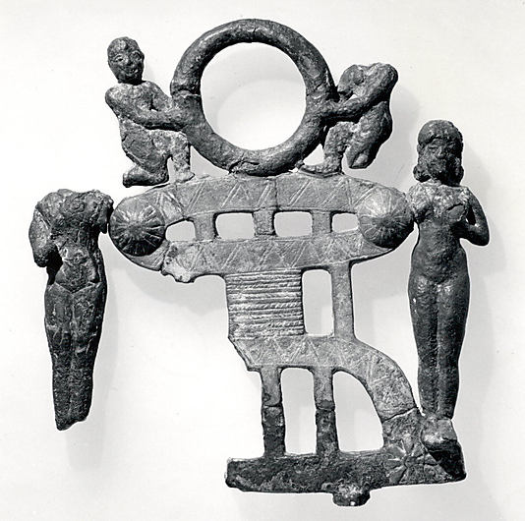
Date: ca. 2000–1600 B.C.
Geography: Mesopotamia
Culture: Babylonian

